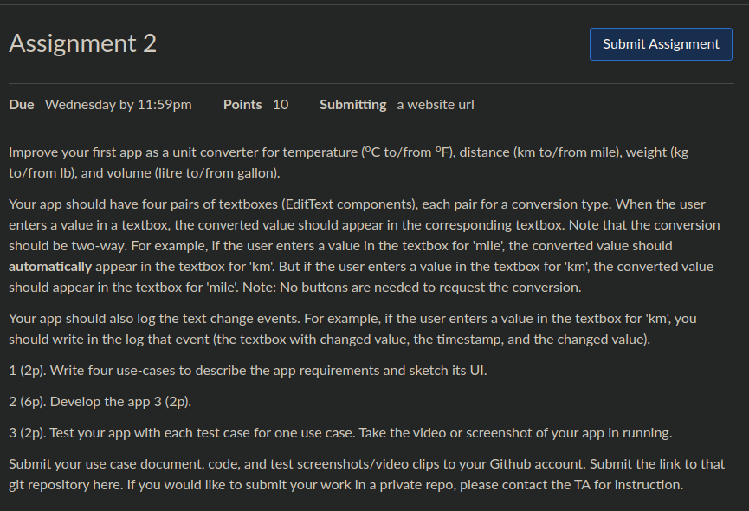

1. - As a user, I want to convert degrees in F to degrees in C

- As a user, I want to convert kg to lb

-As a user, I want to convert lb to kg

-As a user, I want to convert litre to gallon

2. Done

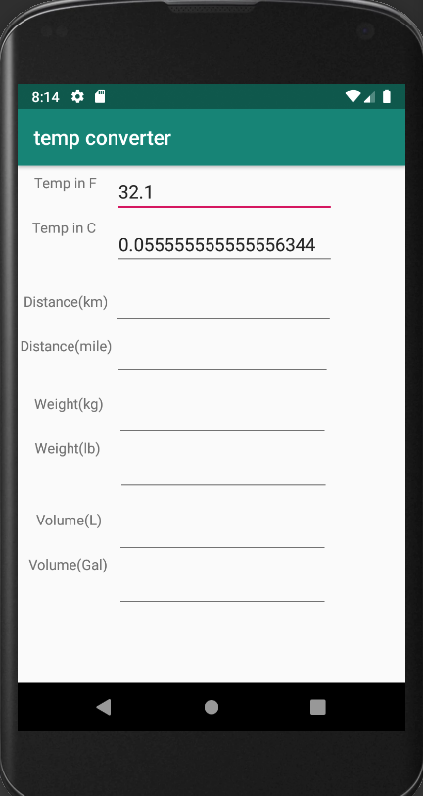3. Test 1:

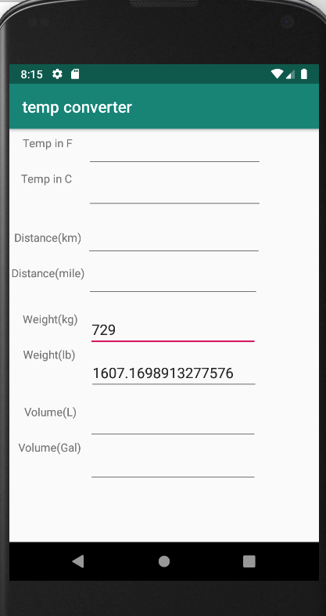Test 2:

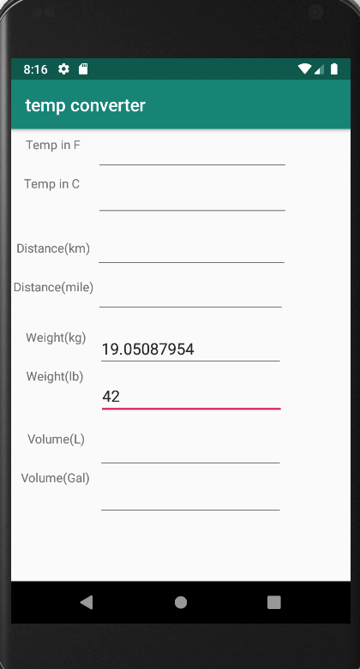Test 3:

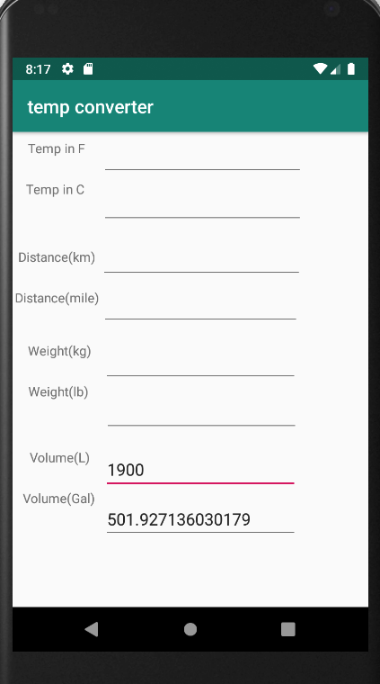Test 4: